**Javascript APIs**

JavaScript provides several powerful APIs that extend its functionality and enable developers to create richer and more interactive web applications. These APIs are part of the browser environment and allow JavaScript to interact with various system features such as file handling, clipboard management, and running tasks in the background.

This documentation explores some of the commonly used APIs that enhance JavaScript's capabilities:

1. **Clipboard API**
2. **File API**
3. **Web Workers API**

**Clipboard API**

The Clipboard API allows web applications to interact with the user's clipboard (cut, copy, and paste operations). It provides more control over clipboard actions compared to the traditional document.execCommand() method and enables programmatic access to copy and paste operations.

**Features:**

* Supports copying and pasting text and images.
* Offers a more secure and modern alternative to document.execCommand().
* Allows access to clipboard content using JavaScript (with user permission).

**Use Cases**

1. **Copying text to clipboard:** Custom copy-to-clipboard buttons.
2. **Clipboard management:** Implementing features like copying code snippets, URLs, or other content.

**Example**

**Copying Text to Clipboard**

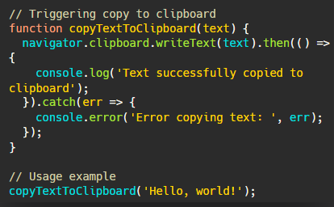

**Pasting Text from Clipboard**

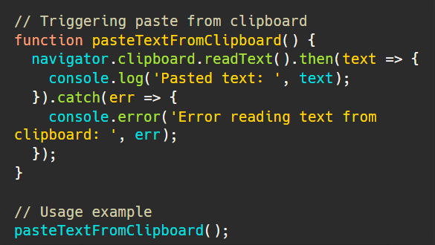

**Security Considerations**

* Clipboard operations require user interaction (e.g., clicking a button) due to security and privacy concerns.
* Access to the clipboard might be restricted in some browsers, especially when not triggered by a user action.

**File API**

The File API provides the ability to read and manipulate files on the client-side. It enables web applications to interact with files selected by the user, such as images, documents, and more. This API is essential for handling file uploads, allowing the application to preview, read, and validate files before they are sent to a server.

**Features:**

* Allows reading file metadata (e.g., name, size, type).
* Can read file contents using FileReader, Blob, and File objects.
* Supports drag-and-drop file uploads and file selection via <input type="file">.

**Use Cases**

1. **File upload functionality:** Handle user uploads of images, documents, or other files.
2. **File preview:** Display a preview of selected images or other files before uploading them.
3. **File validation:** Ensure uploaded files meet the required formats and sizes.

**Example**

**Reading a File Using FileReader**

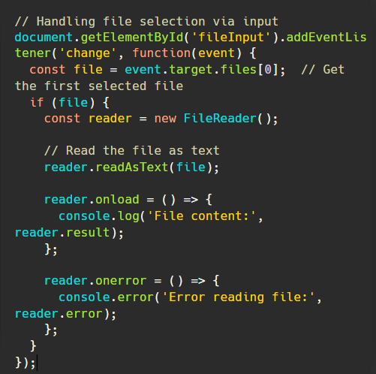

**File Upload Example with Form**

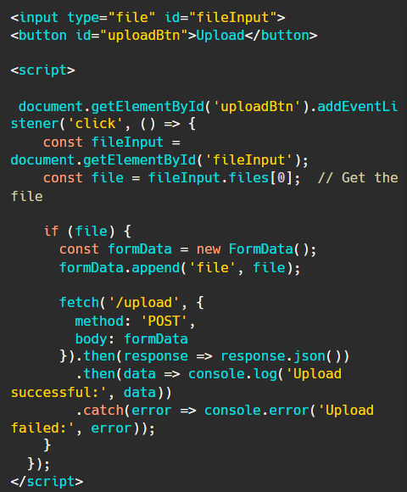

**Security Considerations**

* The File API allows reading files from the user's local machine, but access is restricted to files selected by the user through an <input> element or drag-and-drop.
* Files should not be stored or transmitted without proper validation to ensure that the content is safe (e.g., checking for malicious scripts in uploaded files).

**Web Workers API**

The Web Workers API enables JavaScript to run scripts in the background, in separate threads, without blocking the main UI thread. This allows long-running tasks (e.g., data processing, heavy computations) to be executed without freezing or slowing down the user interface.

**Features:**

* Offloads computations to background threads.
* Can be used to run tasks asynchronously while keeping the UI responsive.
* Supports communication between the main thread and workers using messages.
* Web workers run in a separate global context, so they don’t have access to the DOM or the window object.

**Use Cases**

1. **Complex data processing:** Run large calculations without blocking the UI.
2. **Background tasks:** Perform background tasks like data fetching, video processing, or machine learning model inference.
3. **Multithreading:** Take advantage of multi-core processors to speed up computations.

**Example**

**Creating a Web Worker**

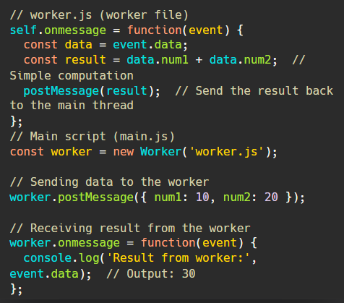

**Terminating a Worker**



**Security Considerations**

* Web Workers run in a separate global context and cannot access the DOM, window object, or most web APIs. This is a security feature to isolate the worker from the main thread.
* Web Workers do not have access to certain browser features (e.g., localStorage), but they can communicate with the main thread via the postMessage() API.

**Further Reading and Resources:**

* [**https://developer.mozilla.org/en-US/docs/Web/API/Clipboard_API**](https://developer.mozilla.org/en-US/docs/Web/API/Clipboard_API)
* [**https://developer.mozilla.org/en-US/docs/Web/API/File_API**](https://developer.mozilla.org/en-US/docs/Web/API/File_API)
* [**https://developer.mozilla.org/en-US/docs/Web/API/Web_Workers_API**](https://developer.mozilla.org/en-US/docs/Web/API/Web_Workers_API)